2200030216 JUNIT TESTING   
EXERCISE -4  
Arrange-Act-Assert (AAA) Pattern, Test Fixtures, Setup and Teardown Methods in JUnit

OUT PUT   
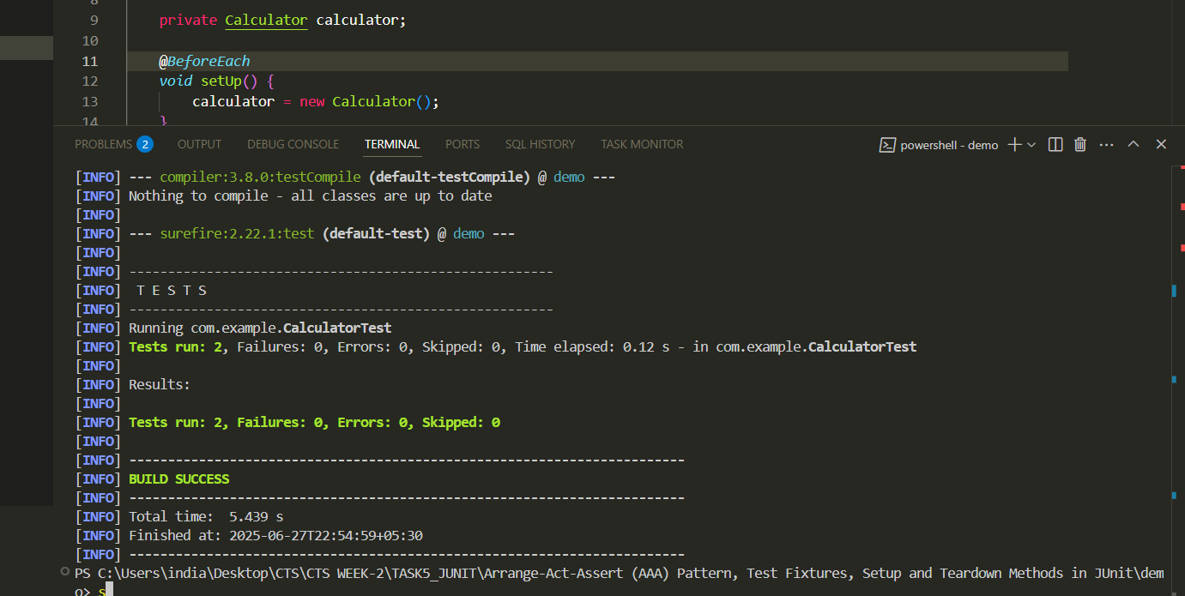

Files format  
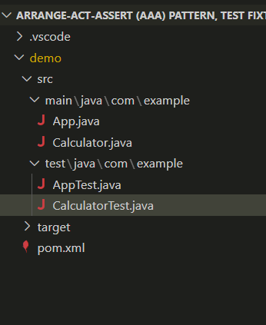

Calculator.java  
package com.example;

public class Calculator {

    public *int* add(*int* *a*, *int* *b*) {

        return *a* + *b*;

    }

    public *int* subtract(*int* *a*, *int* *b*) {

        return *a* - *b*;

    }

}

calculatorTest.java  
package com.example;

import org.junit.jupiter.api.\*;

import static org.junit.jupiter.api.Assertions.\*;

public class CalculatorTest {

    private Calculator calculator;

    @*BeforeEach*

*void* setUp() {

        calculator = new Calculator();

    }

    @*AfterEach*

*void* tearDown() {

        calculator = null;

    }

    @*Test*

*void* testAddition() {

*int* result = calculator.add(2, 3);

        assertEquals(5, result);

    }

    @*Test*

*void* testSubtraction() {

*int* result = calculator.subtract(10, 4);

        assertEquals(6, result);

    }

}